**EXPERIMENT 06**

**AIM:** To Develop an Application that reads and writes data to an SD CARD

**OUTPUT:**

Used the feature to work as a note taker while SCRUM MEETINGS are held.

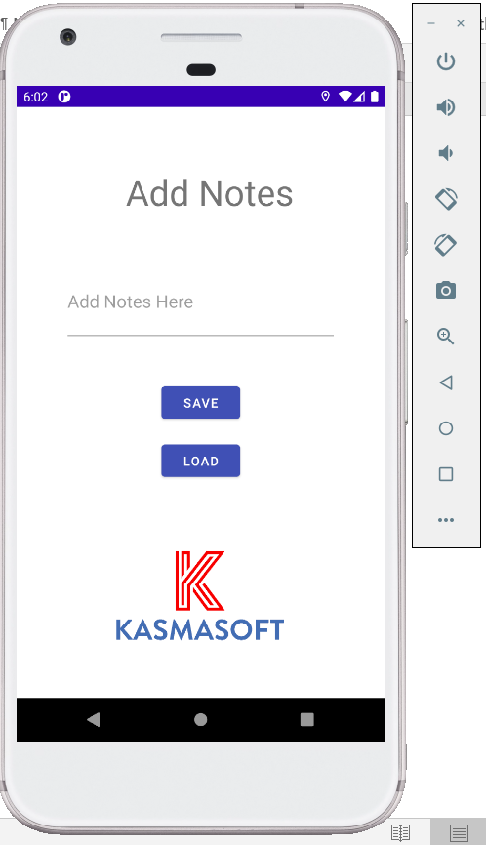 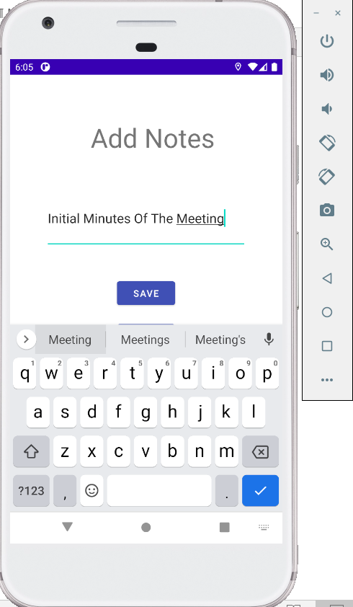

**SAVING THE NOTES**

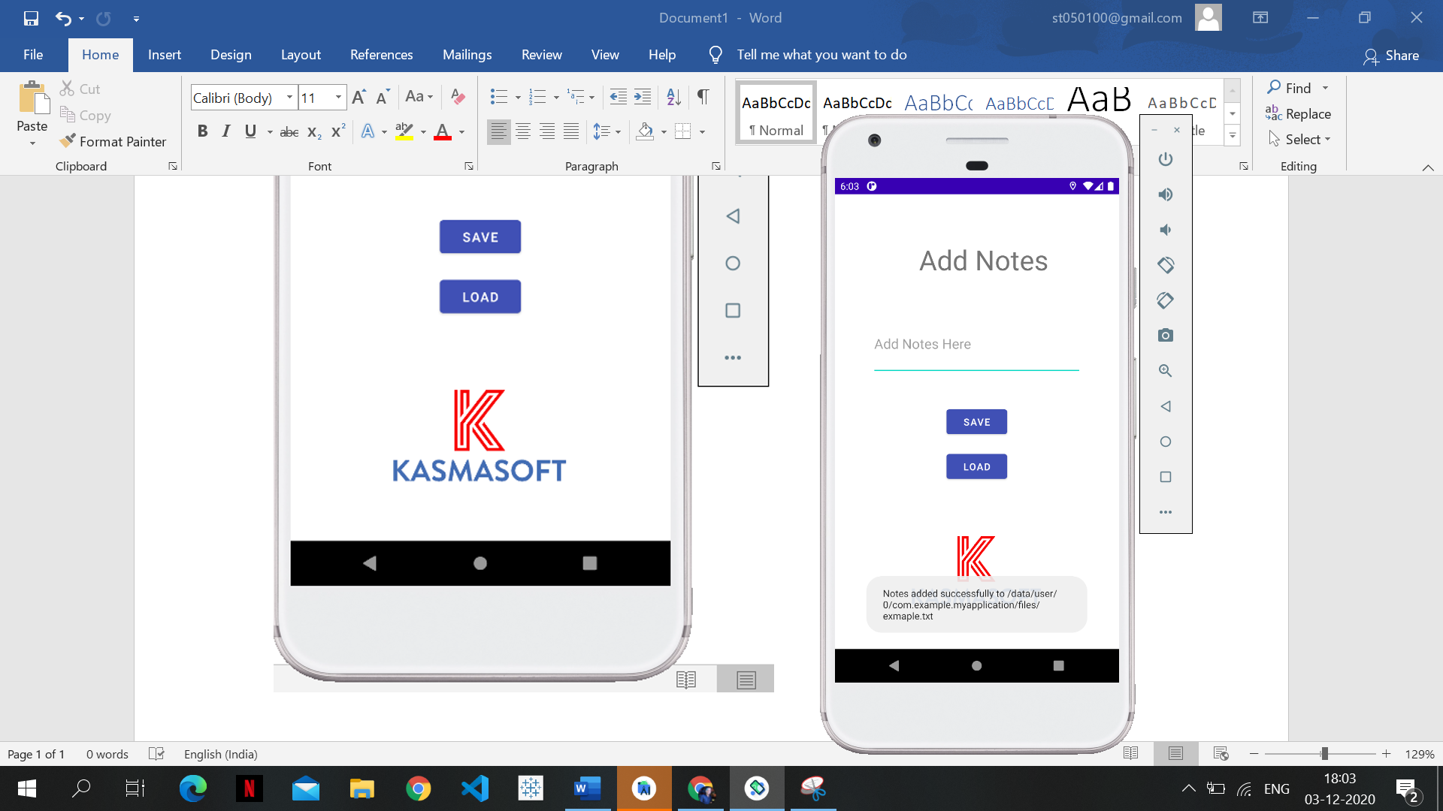

**LOADING THE NOTES BACK**

